BREEDING RABBIT CARE INFO SHEET

BREEDING RABBIT START UP
- A good, competitive breeding rabbit will cost $50-$200, and can go up from there. However, students can compete with a solid $50 rabbit as long as it comes from a reputable breeder!
  - Some sell rabbits for as low as $35, however be aware of “pet quality” vs “show quality”
- Aging a rabbit depends on the breed- several rabbits are good for years however most are prime show quality for one year. Check with your ag teacher for advice and help on this.
- A student may show as many breeding rabbits as they want, and can be a variety of breeds.

COSTS TO EXPECT AFTER PURCHASING THE ANIMAL:
- Your rabbit’s amount of feed will vary based off of what breed it is. Some breeds each ¼ cup 2x daily while some go to “free feeding” (leaving ample amount of food constantly).
  - However, when caring for 1 rabbit a 50lb bag of feed will last a long time!
  - Feed will usually cost $12-$20 per bag
- Timothy hay should be provided (small handful each day)
- A small animal or baby scale should be purchased ($30-70 depending on what you get)
- A cage that has NO solid bottom
- Feeder, waterer and foot mat

SHOPPING LIST
- Foot mat (this can be purchased off of Amazon)
- Ceramic water bowl (a bowl needs to be used for larger breeds such as Californians, Cinnamons, Champagne D’Argents, standard rex, etc).
- Waterer (the drip waterers can be used for smaller breeds, however if you prefer a bowl, that is recommended).
- Feeder
- Saw blade for grooming (rex breeds only)
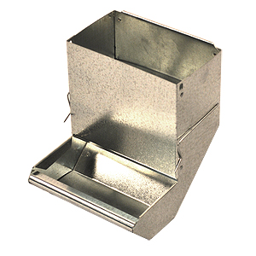
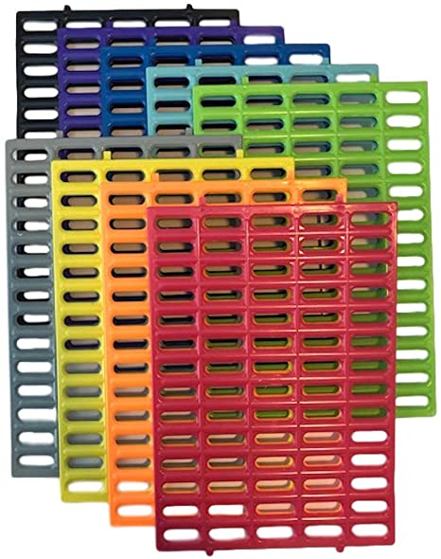

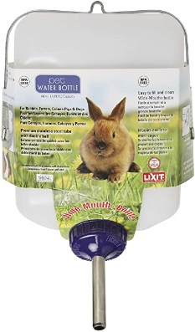

MAKING SURE YOU ARE SHOW READY:
- Does your rabbit have a tattoo in their ear?
- Do you know the gender of your rabbit?
- Does your rabbit have all of its toes? (1 missing toe will DQ your rabbit, and on occasions, their feet can get caught in the wire and tear off their toes)
- Are your rabbits nails clipped to an appropriate length?
- Is your rabbit weighing in correctly?
- Are your rabbit’s teeth properly aligned?
- Check with the ARBA Book of Standards to make sure your rabbit fits in all parameters of the breed’s requirements
DAILY CARE:
- Working with your rabbits fur
  - This shouldn’t take much time unless they are in the process of molting.
  - Spend 3-5 minutes each day tending to their fur. Their fur is a large portion of their overall “score”
  - Rex Breed rabbits: take a small reciprocating saw blade and brush from the tail to the neck. All loose hair will come out and continue to brush until little to no hair comes loose.
  - “Fly back” hair breed rabbits: Take your hand and brush from the tail to the neck a few strokes, then one stroke from the neck to the tail. Repeat several times until loose hair is no longer coming out.
- Practice putting your rabbit in show position (this is also the position you brush them in)
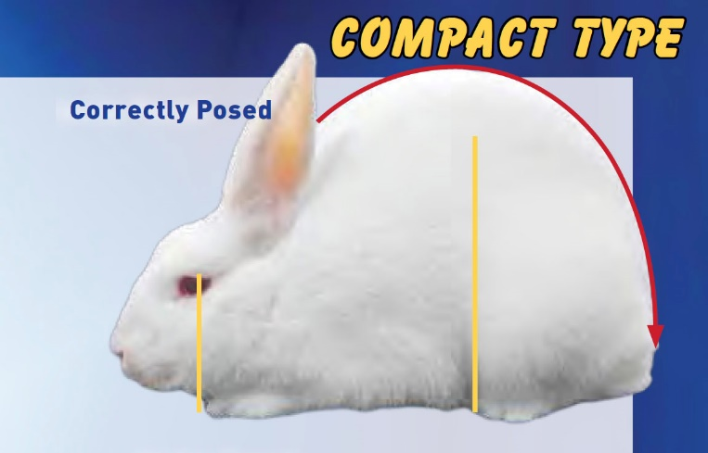
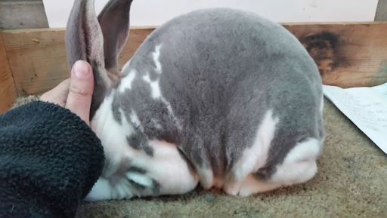

- Turn your rabbit over several times a week to get used to handled by the judge.
- Check about 2-3 weeks for long nails
  - Be sure to not cut them too short (past the quick)

TAKING CARE OF SICK RABBITS:
- Ear Mites: give 2 drops ivermectin in each ear (repeat every 3 days until it is cleared up. However it will usually clear up after the first dose).
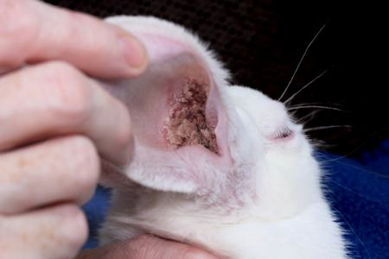
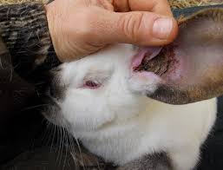
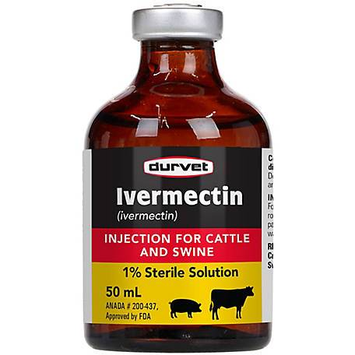

- Ear Infection: If you notice your rabbit not eating as much, accompanied with either an ear flopped down, pus in the ear and eye, and/or build up in the ear.
  - 2 drops penicillin in the ear for several days
  - Offer hay to help settle the stomach

- Diarrhea: Separate the rabbit IMMEDIATELY from any others you have and offer it only hay and clean water.
  - It is hard for rabbits to “bounce back” when they get too far gone, and diarrhea is usually a hard one to come back from. However try the full hay diet and don’t give up.

- Rabbit not eating: before freaking out on this one, understand there are times that rabbits won’t eat as much as usual. When weather shifts, it can cause them to not eat as much.
  - If the not eating persists for more than 2 days, offer hay and make sure water is 100% clean and in a bowl.
  - Check for mites and ear infections

**Any time you notice a rabbit acting sickly, remove it from the rest of the herd and clean out the cage and all feeders, waterers and foot mats**

FEEDING:
- Feeding will be determined by breed, however here are some common breeds and what they need

¼ Cup 2X Daily | ½ Cup 2X Daily | 1 Cup 2X Daily/ Free Feed
Mini Rex  Havana  Polish | Junior Standard Rex  Junior D’Argents  Harlequin  Mini Lop | Californians  Cinnamons  Senior Standard Rex  Senior D’Argents  French Lops

- Rabbits should be fed twice daily, and clean water regularly.
  - DO NOT just keep topping off the water bowl if it has dirt, hair, poop, etc. in it!!
- Local feed is ManaPro from Tractor Supply
  - However, Petrus is sold in Alexandria, LA and is higher quality
- Timothy hay should be given once a day (small handful)
  - If your rabbit is beginning to break weight, take the hay out of their diet
- Toilet paper/paper towel rolls can be given to them to chew on
- Water needs to be kept CLEAN.
  - Change it out at least once a day!

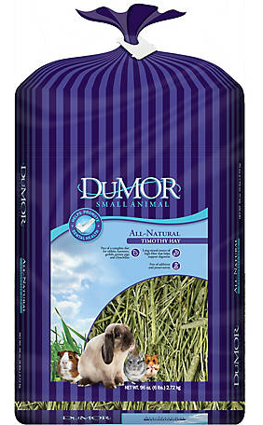
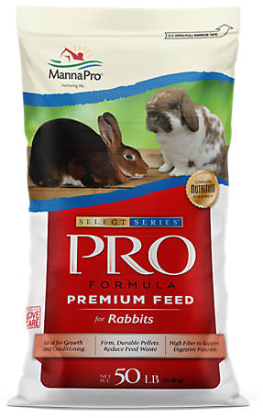

HOUSING:
- Your rabbit’s cage needs to be hanging, or elevated over a catch tray that allows droppings to fall through the wire
  - Your rabbit shouldn’t be sitting on their feces and urine!
  - Make sure the wire on the bottom of the cage is big enough to allow poop to go through
- Your rabbit needs to have a cool, covered, space out of direct sunlight
  - Don’t have direct sunlight on your rabbit because it can bleach out their fur
  - Your rabbit needs to have fans, window unit, or something that allows them to stay cool
    - Rabbits prefer the cold! They are perfectly happy at 30* weather (as long as wind isn’t directly blowing on them)
  - Make sure there is no way for your rabbit to get wet!

