MARKET RABBIT CARE INFO SHEET
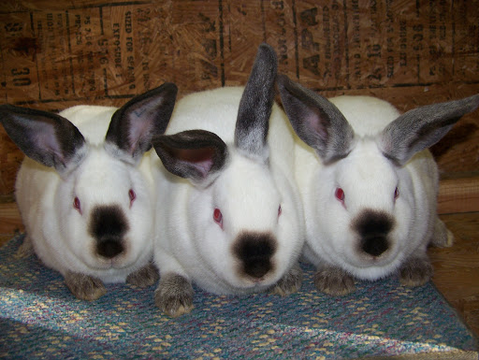

MARKET RABBIT START UP
- A good, competitive meat rabbit will cost about $50 each, and can go up from there. However, students can compete with a solid $50 rabbit as long as it comes from a reputable breeder! (Your whole pen will cost $200-$250 in most cases).
  - A student will show minimum of 4 rabbits in a pen, so it is suggested to buy 5 in case something happens to one.
- Order your pen of rabbits WAY ahead of time. Most breeders need several month’s notice to be able to fill orders. Talk with your AST about finding a good breeder!!
- You will get your meat pen at 6 weeks old and raise them for about 6 more weeks
- Common meat pen breeds include: Californians, Cinnamons, New Zealands
COSTS TO EXPECT AFTER PURCHASING THE ANIMAL:
- Your rabbit’s feed is not incredibly expensive and will last a good while.
- You shouldn’t use more than 2-3 bags in the 6 weeks you raise them
  - Feed will usually cost $12-$20 per bag
- Timothy hay should be provided (small handful each day)
- Possibly a few extra supplements to feed- go off of your AST’s advice
- A small animal or baby scale should be purchased ($30-70 depending on what you get)
- A cage FOR EACH INDIVIDUAL RABBIT that has NO solid bottom
  - They do not need to share cages- this will allow for fighting, hair pulling, and uneven feeding
- Feeder, waterer and foot mat for each rabbit

SHOPPING LIST (for EACH rabbit)
- Foot mat (this can be purchased off of Amazon)
- Ceramic water bowl
  - Meat pen rabbits do not need to use the drip waterers- a bowl allows them to grow much better.
- Feeder
- Piece of carpet or rug to groom rabbit on so they don’t slip

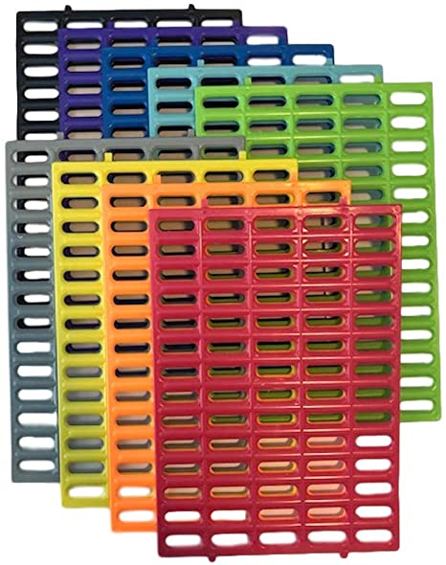
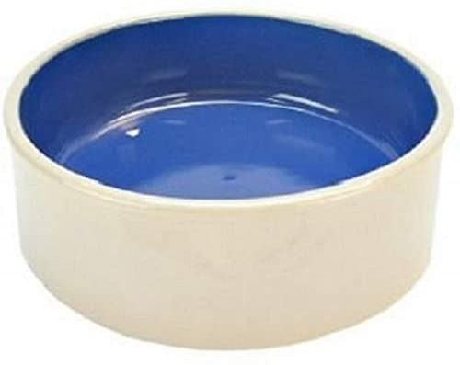
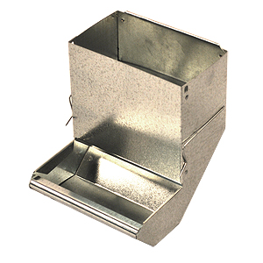

MAKING SURE YOU ARE SHOW READY:
- Do all of your rabbits have a tattoo in their ear?
- Do all of your rabbits have all of its toes? (1 missing toe will DQ your rabbit, and on occasions, their feet can get caught in the wire and tear off their toes)
- Are your rabbits’ nails clipped to an appropriate length?
- Are your rabbits weighing in correctly?
- Are your rabbits’ teeth properly aligned?
- Check with the ARBA Book of Standards to make sure your rabbit fits in all parameters of the breed’s requirements

DAILY CARE:
- Working with your rabbits fur
  - This shouldn’t take much time unless they are in the process of molting.
  - Spend 3-5 minutes each day tending to their fur. Their fur is a large portion of their overall “score”
  - “Fly back” hair breed rabbits: Take your hand and brush from the tail to the neck a few strokes, then one stroke from the neck to the tail. Repeat several times until loose hair is no longer coming out.
- Practice putting your rabbit in show position (this is also the position you brush them in)
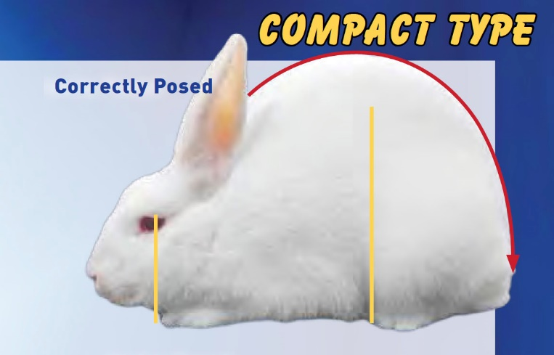
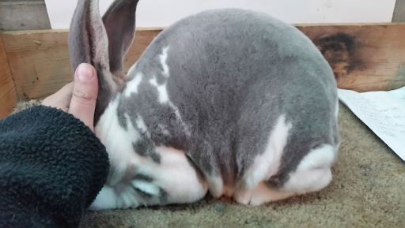

- Turn your rabbit over several times a week to get used to handled by the judge.
- Check about 2-3 weeks for long nails
  - Be sure to not cut them too short (past the quick)
- Check your show’s weight requirements and weigh your rabbit every other day to make sure they are not going to break or miss weight.
  - If you notice them gaining too much, cut back feed for a week to 1 cup a day
    - If they still are too big, take away hay
  - If your rabbit isn’t gaining enough, add more feed and hay

TAKING CARE OF SICK RABBITS:
- Ear Mites: give 2 drops ivermectin in each ear (repeat every 3 days until it is cleared up. However it will usually clear up after the first dose).
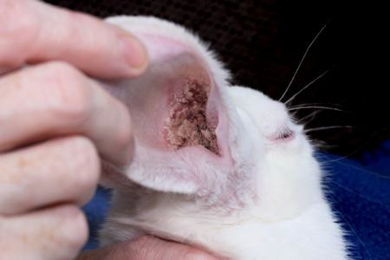
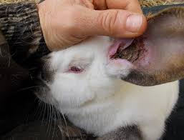
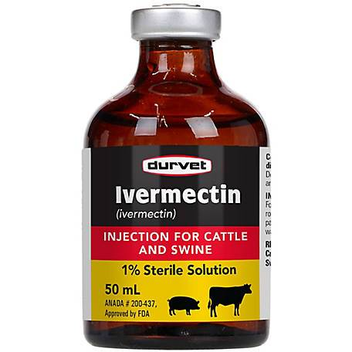

- Ear Infection: If you notice your rabbit not eating as much, accompanied with either an ear flopped down, pus in the ear and eye, and/or build up in the ear.
  - 2 drops penicillin in the ear for several days
  - Offer hay to help settle the stomach

- Diarrhea: Separate the rabbit IMMEDIATELY from any others you have and offer it only hay and clean water.
  - It is hard for rabbits to “bounce back” when they get too far gone, and diarrhea is usually a hard one to come back from. However try the full hay diet and don’t give up.

- Rabbit not eating: before freaking out on this one, understand there are times that rabbits won’t eat as much as usual. When weather shifts, it can cause them to not eat as much.
  - If the not eating persists for more than 2 days, offer hay and make sure water is 100% clean and in a bowl.
  - Check for mites and ear infections

- Bloating rabbit: Give baby gas drops relentlessly

**Any time you notice a rabbit acting sickly, remove it from the rest of the herd and clean out the cage and all feeders, waterers and foot mats**
FEEDING:
- Rabbits are noctournal and will eat more at night
- Do NOT miss a meal- provide feed for your rabbit at all times
  - My personal advice: offer 1 cup at a time and put feed in there regularly so it stays fresh. DO NOT pile up a ton of feed (especially if you are in a humid area)
  - Feed and water needs to look appealing to rabbits, if it looks like something you wouldn’t eat/drink, they won’t either
  - DO NOT just keep topping off the water bowl if it has dirt, hair, poop, etc. in it!!
- Local feed is ManaPro from Tractor Supply
- Timothy hay should be given once a day (small handful)
  - If your rabbit is beginning to break weight, take the hay out of their diet
- Put 2-3 sunflower seeds in their feed each day to help with hair coat
  - Do NOT give them too many, they will start to refuse feed if they get these “treats” too often
- Toilet paper/paper towel rolls can be given to them to chew on

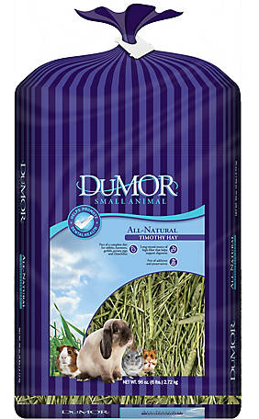
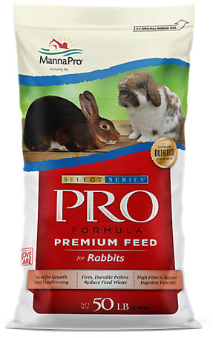

HOUSING:
- Keep rabbits together 3-5 days to reduce stress. After that period, put each rabbit in a separate pen
- Your rabbit’s cage needs to be hanging, or elevated over a catch tray that allows droppings to fall through the wire
  - 24” x 24” is ideal size for each rabbit
  - Your rabbit shouldn’t be sitting on their feces and urine!
  - Make sure the wire on the bottom of the cage is big enough to allow poop to go through
- Your rabbits needs to have a cool, covered, space out of direct sunlight
  - Don’t have direct sunlight on your rabbit because it can bleach out their fur
  - Your rabbit needs to have fans, window unit, or something that allows them to stay cool
    - Rabbits prefer the cold! They are perfectly happy at 30* weather (as long as wind isn’t directly blowing on them)
  - Make sure there is no way for your rabbit to get wet!
