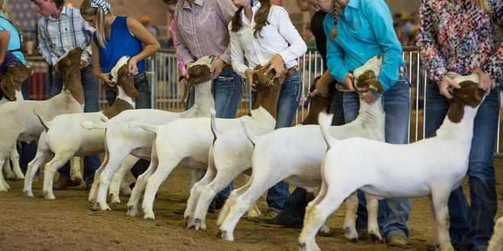

LAMB/GOAT START UP:
- Modern show lambs and goats usually look their best at about 8-10 months of age. So, when purchasing your animal, select appropriate aged wethers for the show you plan to go to.
- A competitive lamb will cost at least $500-750+, you can get one for less if you look hard. Expect to spend a MINIMUM of $400.
  - Wethers can get up to $1,500+ however this doesn’t mean you will automatically win. Poor feeding can make a top notch animal go to waste
- Wether Market animal (castrated male)
  - Terminal shows mean the animal will not come home after you show
  - Examples include but not limited to San Antonio, Houston, and some county shows
  - “Premium” shows mean it is non-terminal and animals go home at the end of the show
- When selecting a lamb or goat, talk with your AST to get with a reputable breeder!!
- Remember- your animal will be a little “wild” when you first get it! It is your job to treat it right, and work with them regularly to calm them down. It is easy for judges to tell who does and doesn’t work with their animal.
Costs to Expect (after building a pen):
- Entry Fees
  - Most major shows are $30 per wether
  - Most jackpot shows are about $25 for the show, and $5 for an optional showmanship
- Hotel rooms (if you go to majors)
- Gate and parking passes for major shows
  - Most gate and parking passes are $45 per pass. Exhibitor gets 1 free pass so family must purchase their own
- Feed (Most good quality feeds will cost near $20 per 50lb bag)
- Supplements
- Wormers
- Other Misc. such as tack, lotions, shampoos, etc.
Shopping List:
(Website to purchase: https://www.sullivansupply.com/product-category/goats/)
*can also get most of this at Tractor Supply, stock show vendors, or other feed stores.
- Tube/Sleeve
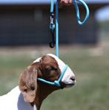
- Elevated Feeding Stand
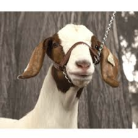
- Hanging Feeder
- Bucket
- Exhibitor Clip
- Halter: Start with nylon/rope- purchase a few
  - Chain for shows (goats only)
- Muzzle
- Cover/blanket
  - Pro Cool for hot days
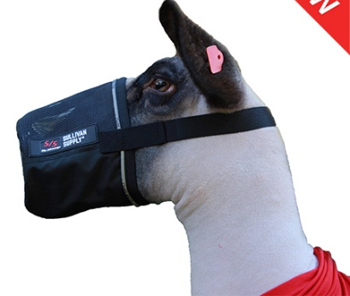
  - Canvas/cloth for cold
- DSMO (lambs for shag care and growth)
- Volumizing shampoo and Mane N Tail Shampoo/Conditioner
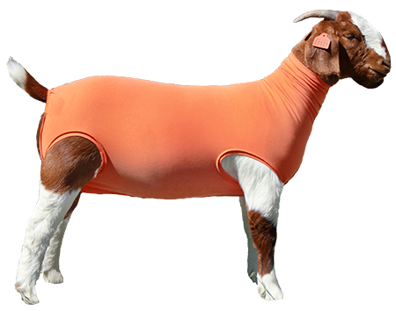
- Food scale (to weigh feed)
- Mini Blower
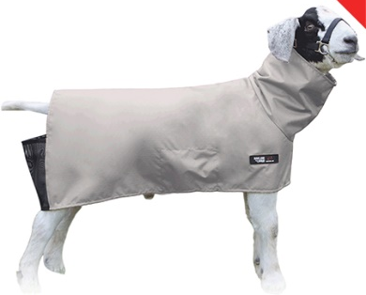
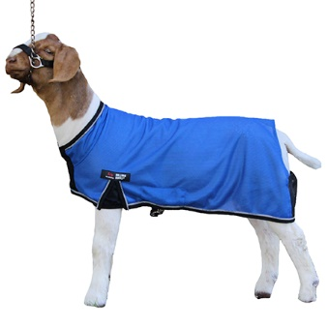

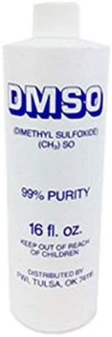

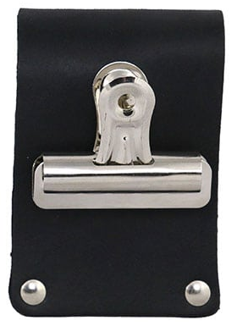
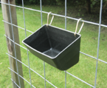
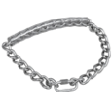

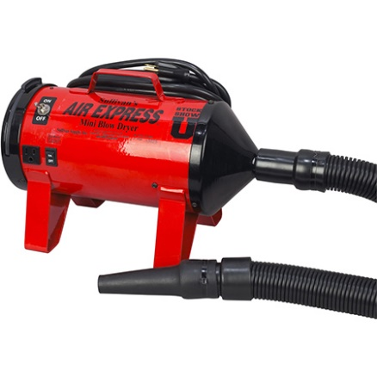

Selecting your Lamb/Goat
- Priorities for selection:
  - Target show (Ex. County only, or major shows)
  - Age & genetics
  - Structure & design
  - Muscle pattern
- The forearm is a key indicator of muscling. It is the only muscle that can be worked out or changed. Muscling is proportional. If the forearm is large, the other muscles should be as well.
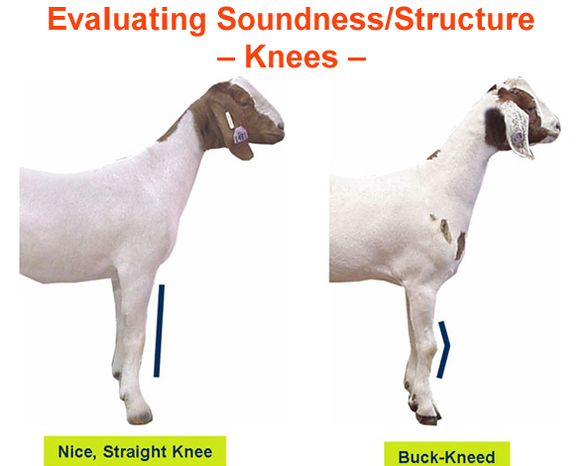
- Look for width in the rack and loin.
- Look for levelness in the hip.
- Look at size of bone.
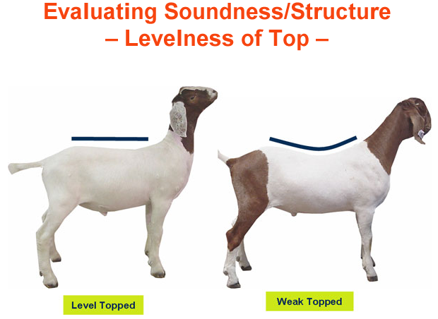
- Look for good dimension of rib shape.

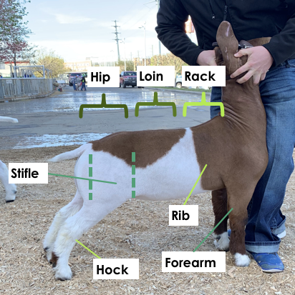
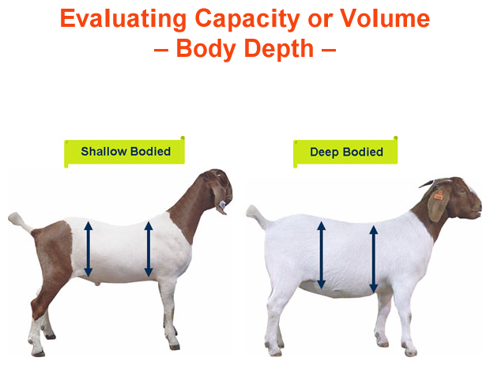

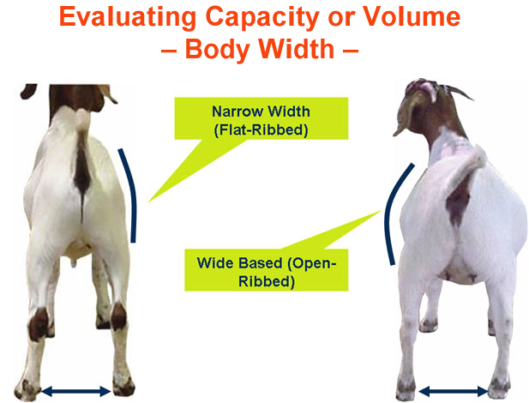

Daily Care: (should take close to 45 minutes to an hour and a half a day)
- Exercise at least 20-30 minutes a day (depending on how fat, muscular, lean, etc. they are)
  - Use a halter for this! Once a week you should use the choke chain show halter (only goats use choke chain!) But don’t do this until your goat is halter broke.
  - Some people invest in a treadmill and have the goat/lamb walk on it
- Needed to keep the animal firm and fit and allows regulation of fat cover.
- Develop a plan that works for you. Build up slowly and monitor muscle and condition.
- Treat the animal as an athlete- We want a sprinter, not a distance runner.
- Goats and lambs should be bathed regularly, but not excessively.
  - If they get filthy, wash them. Or get on a bi-weekly schedule.
    - DO NOT OVERUSE DAWN SOAP! This will dry out their skin
    - Use Dawn to get a tough grease/mud stain out then go over with a conditioner
  - Make sure to dry them off completely before putting them back in the pen
    - ESPECAILLY lambs! The water can get trapped in the wool and create fungus
    - Lambs will naturally be a little “greasy” feeling- do not try and get rid of that!
- Wash with a focus on legs 1-2 times a week
- in the following order to train and promote hair growth:
  - Wash using volumizer shampoo
  - Rinse
  - Condition (Mane n’ Tail works great)
  - Rinse
  - Blow out and comb
  - Use DSMO and water combo to spray on shag 3x a week 3 months before show (lambs)
  - For lambs, follow the same instructions then wrap the legs.
- Goats and lambs should be kept clipped to get a good idea at the animal’s body condition throughout the year- I would suggest clipping once every month or two to keep up with their growth.
  - If you go to jackpots, clip a couple days before the show
    - This will allow any “streaks” from the clippers to go away
  - If you are worried your animal will get cold, purchase blankets and tubes to keep them warm
  - When you are clipping, USE OIL OR KOOL LUBE ON THE CLIPPERS! They will get hot and burn the animal- if you need to take a break to let the clippers cool off, then take one.
  - Make sure to wet a lamb before you begin to clip them
  - Always clip a using a trim stand
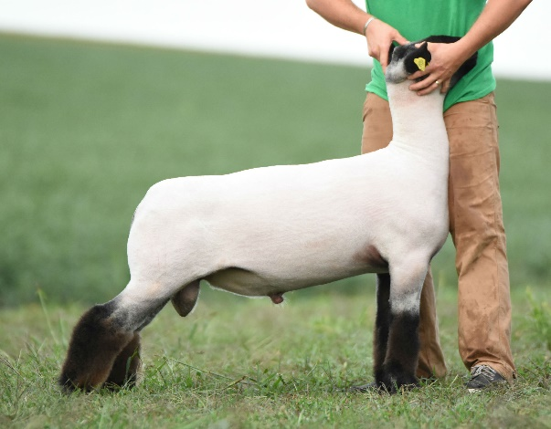
Slick Shear your lambs and goats all over their body except to leave hair at hocks and knees down.
Leave some hair at tip of tail for goats

Showmanship:
- Bracing- one way to teach your lamb to push back against you is to take your lamb or goat to a flatbed trailer and work on pushing them off of it (don’t actually push them off- they know the edge is close and will push back against you trying to hang on)
  - You can go on YouTube and find a lot of good “how to” videos on this
  - Use the picture below as a guide on how to brace your animal for best results
  - Move INTO the animal; always push, never pull
  - Keep head pulled up
  - All 4 feet square
  - Nose down will keep the back level
  - Feet perpendicular to the ground
- Training to Lead
  - They will 99% of the time be wild when you first get them- be patient!
  - Doesn’t happen overnight.
  - Start with a halter and graduate to the chain (for goats)
  - Keep the animal’s head slightly in front of the exhibitor as they walk (if the animal can’t see, they won’t go).
- Show Ring Tips
  - Watch the judge!
  - Pay attention to what the judge wants to see
  - ALWAYS keep the animal between you and the judge
  - Watch your surroundings
  - Leave enough space between you and the next animal
  - If your animal acts up, circle clockwise and put him back in place. It helps him “reset”
  - Show until the very end! Present your animal as if they are the champion.
- Getting ready to show on Show Day
  - On goats, use a little icy hot spray or cream right at the base of the tail to help them keep their tail up
  - Wash goats with “Bright Lights” (purple shampoo) to make them look cleaner
  - Put cold rag on their back to make them “tense up” before entering the ring
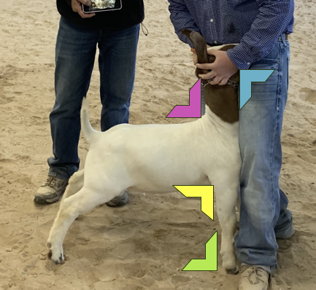
  - Make sure to wash and blow shag!

Feeding:
- Feed at elevated levels- slowly start getting higher and higher to engage their hind muscles
- Goats and Lambs need to be fed good feed in order to be competitive.
- Show Rite is TOP choice by a long shot, but with good exercise and care, you can get away with Purina Honor Show Chow.
- Goats and Lambs should be fed TWICE a day. If they do not eat all of their morning or evening feed, take it away after 30-45 minutes. Keep this up until they learn to finish all their food in one sitting.
- When you first get them, gradually switch to desired feed
- Find out what feed they have been on
  - Week 1: ¾ old feed ¼ new.
  - Week 2: ½ old ½ new.
  - Week 3: ¼ old ¾ new.
  - Week 4: 100% new.
- Keep it simple! There is no “magic formula” that will make your animal an automatic champion. Don’t introduce too many supplements at one time.
  - Introduce supplements one at a time to make sure you know if it is working or not
- Try to feed 1 ½ lbs. to 2 lbs. daily to start.
  - Increase feed as needed, this will depend on the condition of the animal
- Alfalfa and costal hay to help regulate digestion.
  - One handful per day, per animal.
  - Give alfalfa 2-3 times a week at first, you may need to increase or decrease the frequency as the year goes on
- Keep water clean and fresh!!
  - Remember, if you won’t drink it, neither will they.
- If you are feeding multiple goats and/or lambs, DO NOT FEED TOGETHER! You need to be able to monitor consumption for EACH animal separately

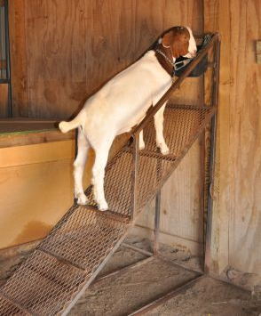

Elevated feeder shouldn’t be THIS steep, but this is the idea. If you aren’t able to build something, stack some cement blocks, build wooden stairs, etc. to have the animal elevated to eat

Common Supplements:
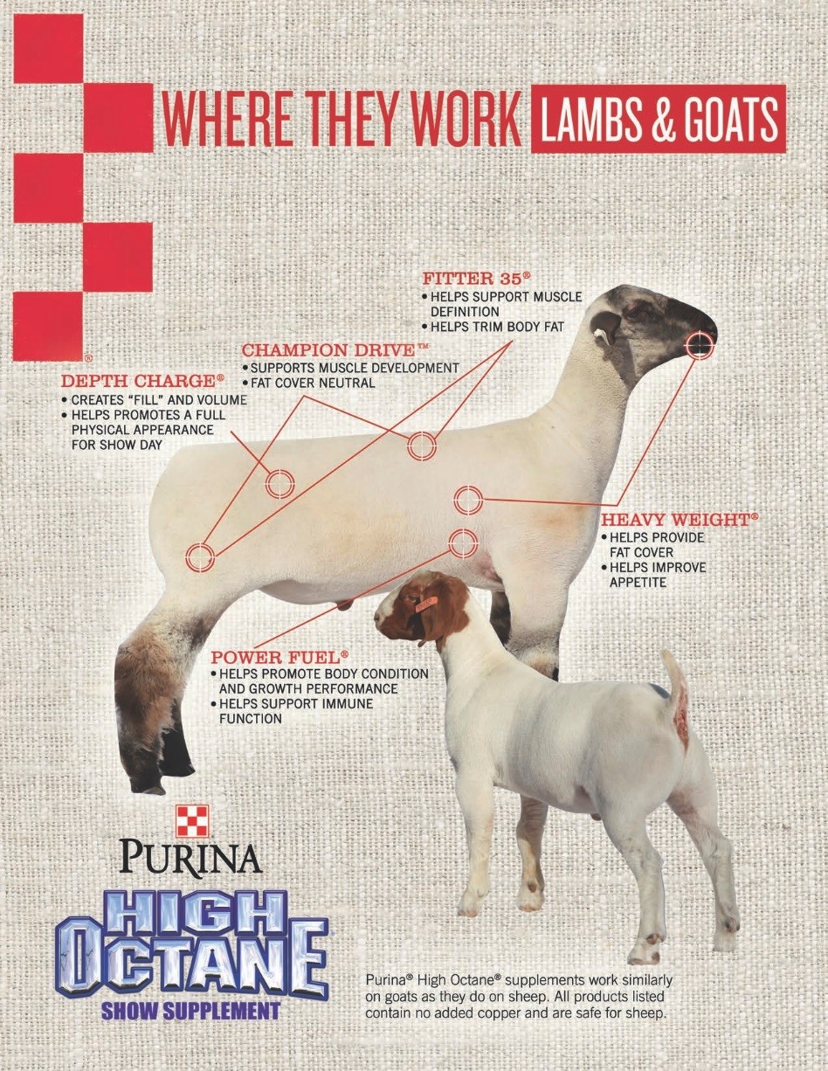

- High Octane Champion Drive: (1lb/day) To help muscling, feed a high protein feed or topdress
- High Octane Ultra Full: (1lb-3lbs per day) For help in the flank area and lower third of the body cavity
- Dyne: (3oz per day) Each ounce of Dyne provides 150 calories for extra energy for peak performance
- Muscle Magic: give 90 days before show. Finishes out your animal.

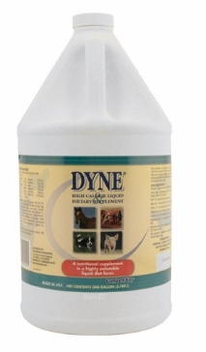
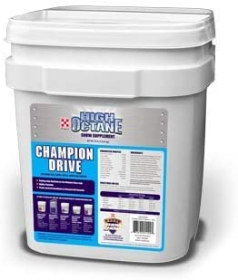

Husbandry:
- Doesn’t have to be elaborate
- Your wether’s pen needs to be large enough for them to be able to move around (minimum 6’X10’)
  - If you have an outdoor pen, I suggest having a 3 and a half sided structure that has shavings/bedding, heat lamp when it’s cold, fan when it’s hot, that they can get out of the weather in.
  - This will 99% likely be the place that they will use for resting and will not poop/pee in this area. However, if they do, you HAVE to change shavings regularly.
- Pay attention to the wind direction, they need good air flow
- Make sure that it has good drainage for when it rains
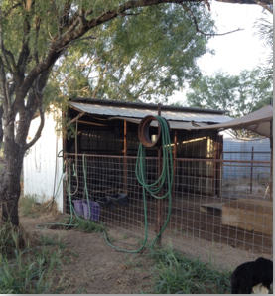
  - DO NOT let it puddle up in the pen- this can cause infection and disease
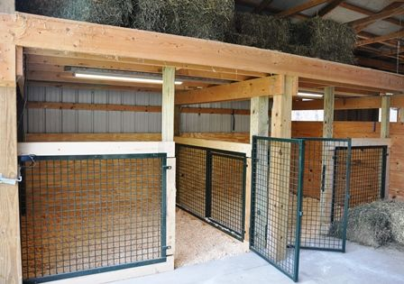
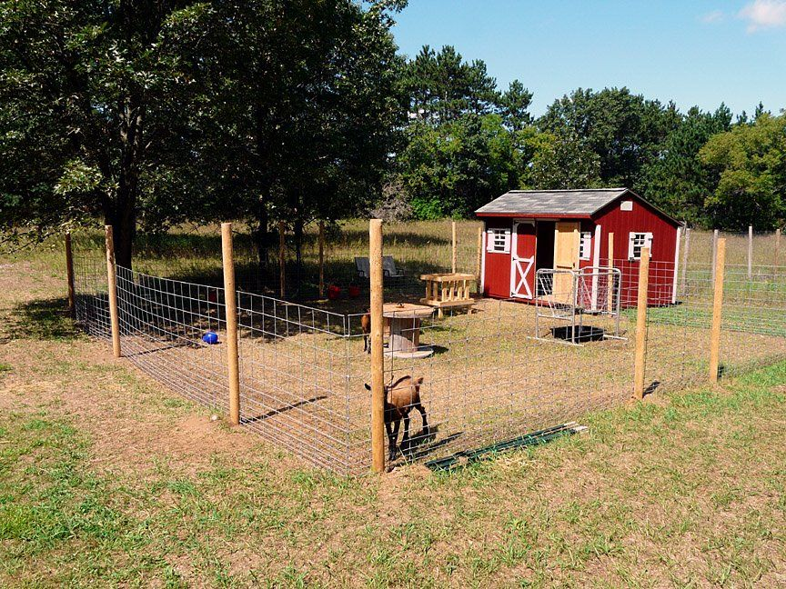
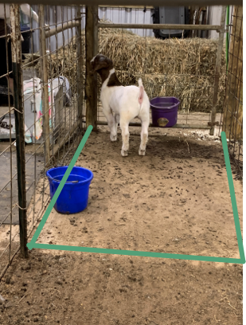

Illness Care:
- Worming
  - deworm every 30 days if on dirt, and 60 days if indoors/on concrete switching between Safeguard and Ivermectin or Synanthic
- Wounds
  - Vetricyn spray
  - Regular doctoring- vet wrap, Neosporin, allowing air to get to wound, etc
- Kidney Stones (Urinary Calculi)
  - Corid: follow directions on bottle to mix with water

- Probiotics - I recommend Doc’s or Probios. Get the paste form!
- Ringworm or other fungus issues
  - Straight apple cider vinegar in a spray bottle
  - Disinfectant and Anti-fungal spray
- Lice
  - Address this RIGHT away!
  - Separate the animal immediately! Lice will spread like wildfire.
  - Wash animal heavy duty with dawn soap
  - Sprinkle 7Dust on your animal to help kill them
  - Clean the pen entirely!
    - Completely replace shavings- MOST IMPORTANT
    - If concrete, wash with bleach
    - Disinfect all feeders and waterers

