Heifer START UP:
- A heifer will cost 2500-3500. This is the average. If you wish to be more competitive you can find them for more. Finding them for less is difficult.
- When selecting a heifer, talk with your Ag Science teacher to get with a reputable breeder!!
- A heifer must be registered with a breed registry.
- A heifer must be state validated. These have hard deadlines to discuss your plans to show a heifer well in advance with your Ag teacher so that you can make sure you get state tags.
- All major shows have hard deadlines well in advance to the show dates. Make sure you communicate with your Ag teacher what shows you wish to attend so that you can meet entry deadlines.
Costs to Expect:
- Entry Fees- Most major shows are $35-60 for the registration of a heifer
- Gate and parking passes for major shows- Most gate and parking passes are $45 per pass. Exhibitor gets 1 free pass so family must purchase their own grounds passes and parking passes if they wish to attend with the exhibitor.
- Feed- Most good quality feeds will be in the $20 per 50lb bag of feed range, if you’re willing to drive I know of a good feed you can get for about $14 a bag but it is in Waxahachie
- Supplements- this will depend on where your heifer is lacking. I have commonly used depth charge and Femininity HP/Fresh and Feminine
- Shavings- usually cost $5 per bag, use multiple bags at a time- you will need shavings for every single show you attend
- A fitter (this is a professional who will give your heifer a haircut prior to shows as well as fit them for fitted shows like Ft. Worth)
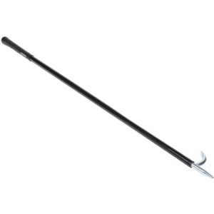
- Other Misc. such as tack, combs, blower, shampoos, sprays, etc.
Shopping List:
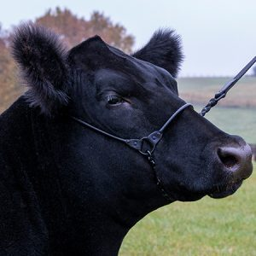
(Website to purchase: Cattle – Sullivan Supply, Inc.)
*can also get some of this at Tractor Supply, stock show vendors, or other feed stores.
- Rope halter
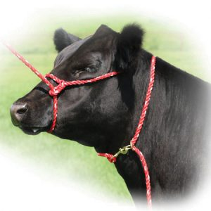
- Neck Tie
- Show Halter
- Show Stick
- Number Harness
- Feed bucket
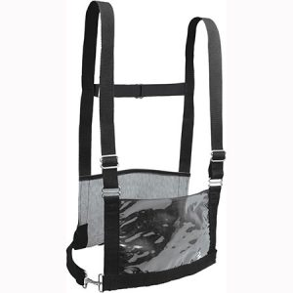
- Water bucket
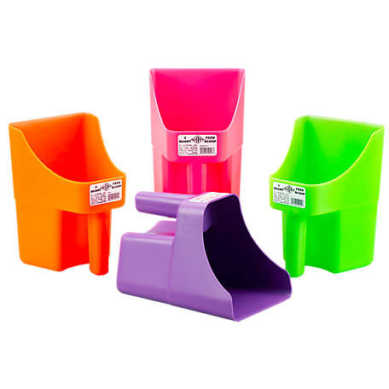
- Feed scoop
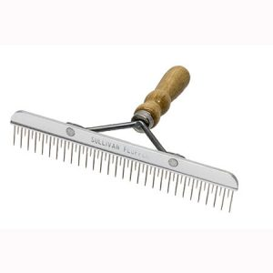
- Blower (to dry hair)
- Comb
- Scrub brush
- Shampoo
- Conditioner
- Shock Spray, Zoom Bloom, Flare, Styling Moose
- Infusium 23 and Mane and Tail Conditioner
- Fly spray
- Spray Bottles
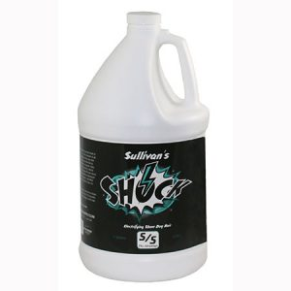
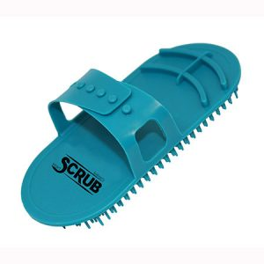
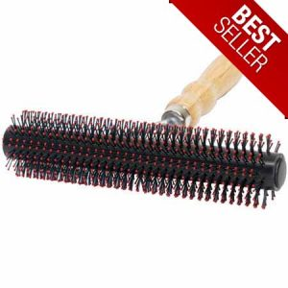

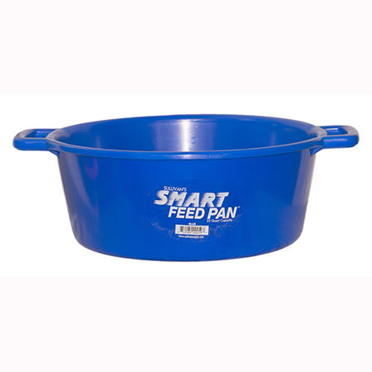
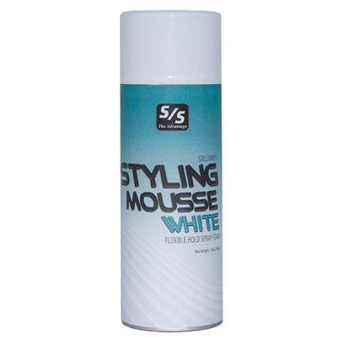
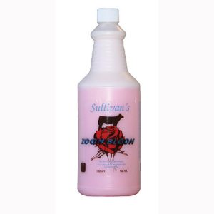

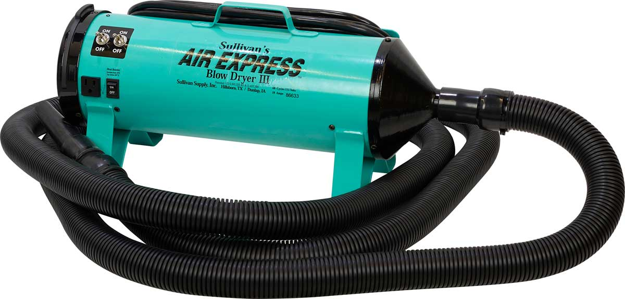

Selecting your Heifer
- Priorities for selection:
  - Reputable, quality Breeder
  - Must be registered
  - Age & genetics
  - Breed- Do you want to work hair? Or no hair?
  - Structure & design
- Look for a strong straight top line that never droops even when the animal relaxes. Show cattle should be long-bodied, clean-front, up-headed and possesses a lot of balance and style.
- You want to make sure the heifer has a productive and maternal look. This entails having a good rib shape, curvature to her rib design, softness to her overall skeleton and power. The heifer needs to have long-tying muscle shape and dimension, and not be just one-dimensional or flat.
- The next selection criteria for a show heifer is balance and eye appeal – you want her to look like a lady.
- She should have a feminine shape to her head and neck and be clean through her throat.
http://afs.ca.uky.edu/livestock/presentation/Judging-Beef-Heifer
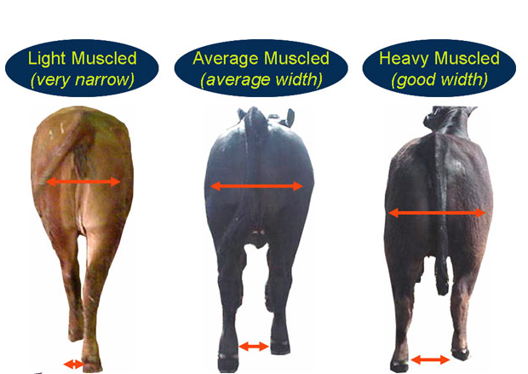
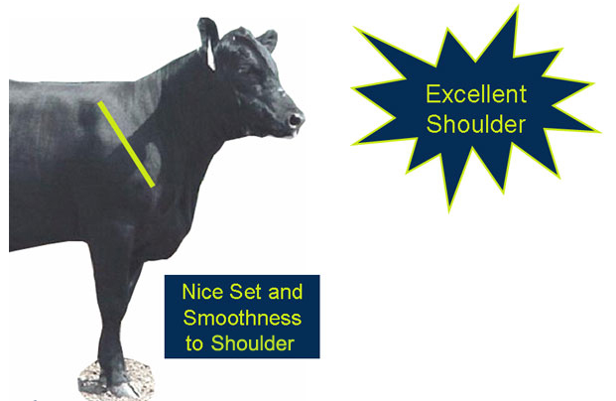
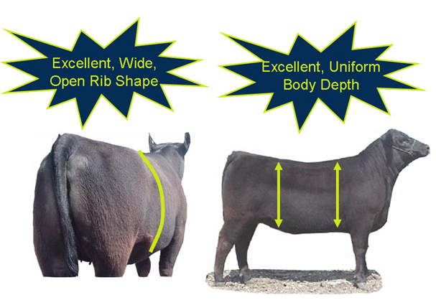
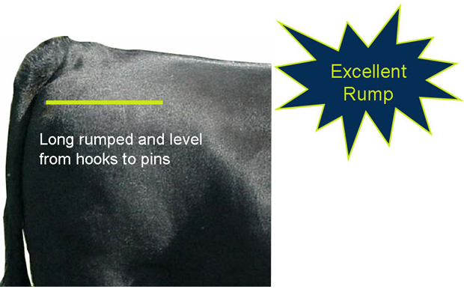
Daily Care:
- Once the heifer is halter broke you should practice walking and setting her up at least 20-30 minutes a day. This is AFTER she will walk on a halter. You want for the both of you to become professionals at setting up. If not set up correctly, the judge cannot see her at her best. Know your heifer weak points and how not to exaggerate them.
- Hair for heifers is super important. Most of your care for your heifer is tending to her hair. To stimulate hair growth, it is common practice to rinse and blow-dry a calf up to twice each day, usually morning and night. Running cold water on your cattle creates circulation and promotes stimulation for hair growth.
  - Your heifer should be rinsed regularly. If you can do it every day then you should.
  - When it is hot, you can comb her hair and let her air dry. If you have electricity in your barn you can rinse her and tie her up under a fan.
  - When it is cool, you need to blow her out. She should not be left wet in the cold weather because she could get sick. When it is excessively cold you can skip the rinse and just condition.
  - DO NOT OVERUSE SOAP. This will dry out their skin. Only bathe her when she needs it. Otherwise, just rinse and condition. You shouldn’t use soap more than once a week.
- Hair should always be combed and blown forward, towards the face.
- The more you condition and train her hair, the better. Purchase Infusium 23 and Mane and Tail Conditioner. Mix these with some water and use a spray bottle to spray this all over your heifer. If you can do this every day, you should. Spray it in and comb her. This can and should also be done after a rinse to recondition her hair.
- You can also do a dump/soak method. This uses more at a time so you may want to do this less often, like once a week. Make a mix of 1 part Infusium, 1 part vinegar and 3 parts mane and tail conditioner. Dump this all over your heifer and comb it in.
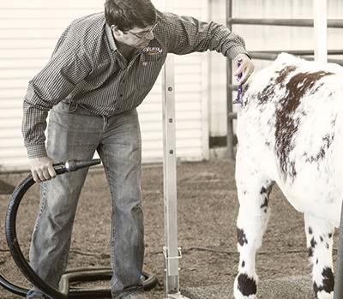
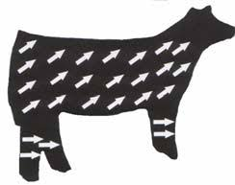

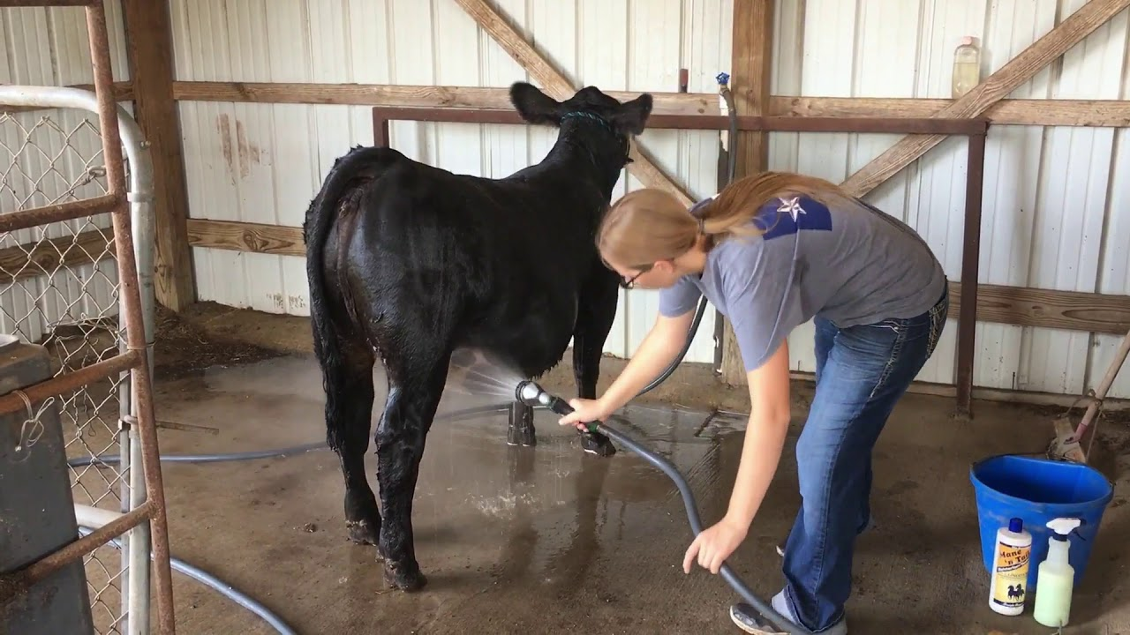

Showmanship:
- Training to Lead
  - They will 99% of the time be wild when you first get them- be patient!
  - Doesn’t happen overnight.
  - Start with a rope halter and work your way to a show halter. You don’t need to practice every day in a show halter but the show should not be the first time she wears it.
- Show Ring Tips
  - Watch the judge! The more eye contact you can make the better
  - Be prepared to answer questions
  - Pay attention to what the judge wants to see (which view and when and where)
  - ALWAYS keep the animal between you and the judge, you should never be blocking the judges view
  - Watch your surroundings
  - Leave enough space between you and the next animal, don’t over crowd
  - Keep a good pace. Don’t let your heifer move too fast or her movements will look choppy
  - Take wide turns
  - Always hold her head UP
  - If your animal acts up, circle clockwise and put her back in place. It helps them “reset”
  - Show until the very end! Present your animal as if they are the champion.
- Setting up
  - You have two views-profile and backend
  - The profile is the side view of your heifer. You will be lined up head to tail. You want her front feet square, her back straight, her head up, and her inside back leg forward. With practice, you can get her to walk into this position.
  - For the back end view you will be lined up side to side, you want all four of her legs square, back straight, and head up.
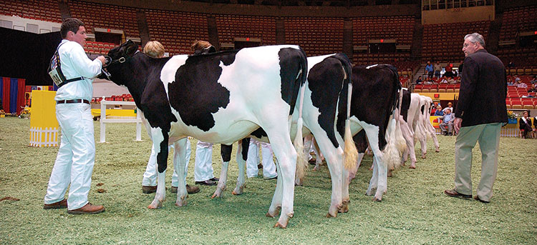
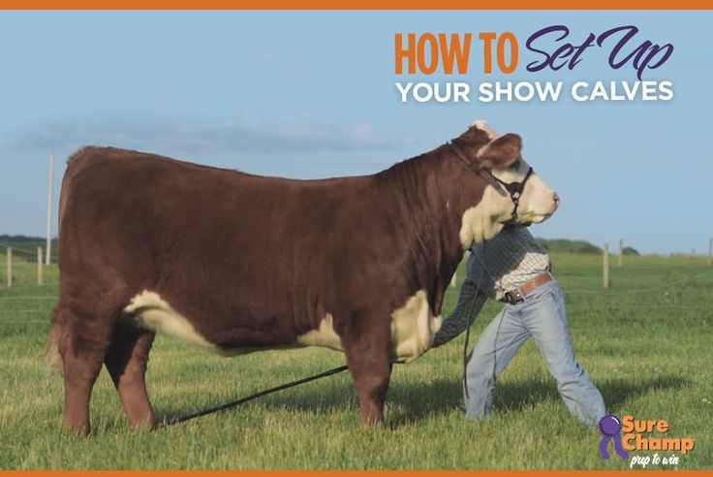

Feeding:
- A heifer needs to be fed twice a day
  - Your heifer should get 4 scoops of feed in the morning and 4 scoops in the evening every day.
  - Be as consistent as possible with the times you feed. A consistent feed schedule is beneficial.
  - Supplements given are on a heifer by heifer basis
  - Your heifer should always have access to clean water
  - You should give your heifer hay every day. 1-2 slices of Sudan hay is best. If not, costal hay will suffice.
- Good choices of feed:
  - ACS Cattle Grower from Ark Country Store in Waxahachie- around $14 for a 50 lb bag
  - Purina has multiple cattle feeds- Full Control, Full Range, Fitter’s Edge, Finishing Touch
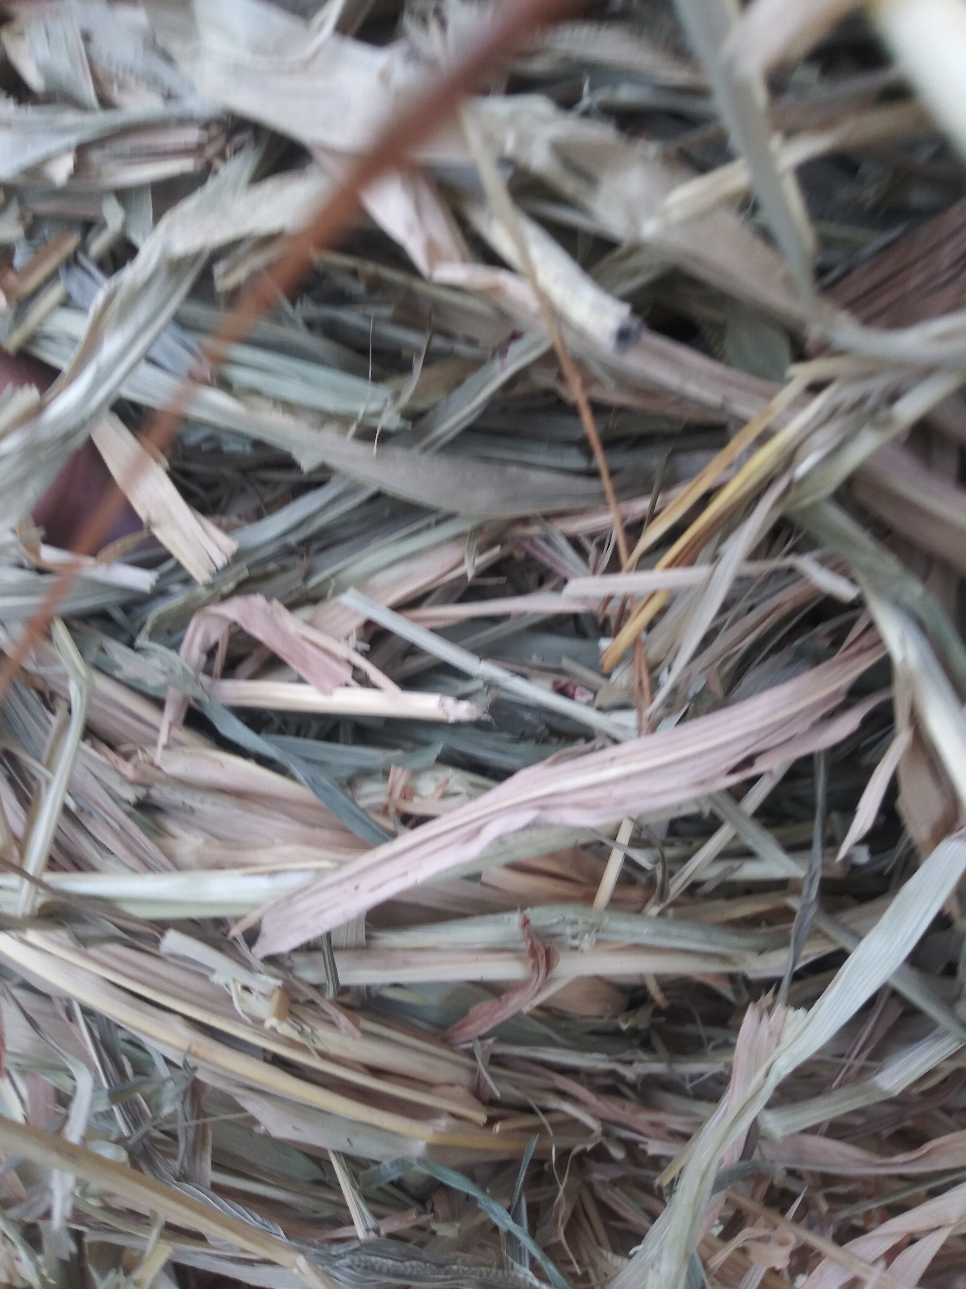
Sudan hay is thicker than costal. It will look like this.

Common Supplements:
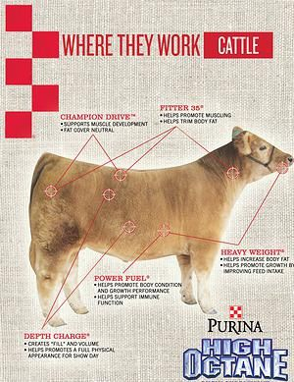
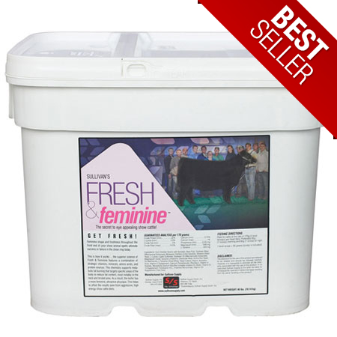

Husbandry:
- Doesn’t have to be elaborate. The school barn is available with electricity and a wash rack if needed.
- Your pen needs to be large enough for them to be able to move around (12x12)
  - If you have an outdoor pen, I suggest having a structure that has fan when it’s hot, that they can get out of the weather in and in the shade.
  - This will 99% likely be the place that they will use for resting and will not poop/pee in this area very much. However, if they do, you have to clean it regularly.
- Make sure that it has good drainage for when it rains. You do not want them living in a mud pit.
- You want access to a hose for drinking water and somewhere to rinse her that won’t get into her pen and make it muddy.
